Manual configuration of Hand Eye:
iOS
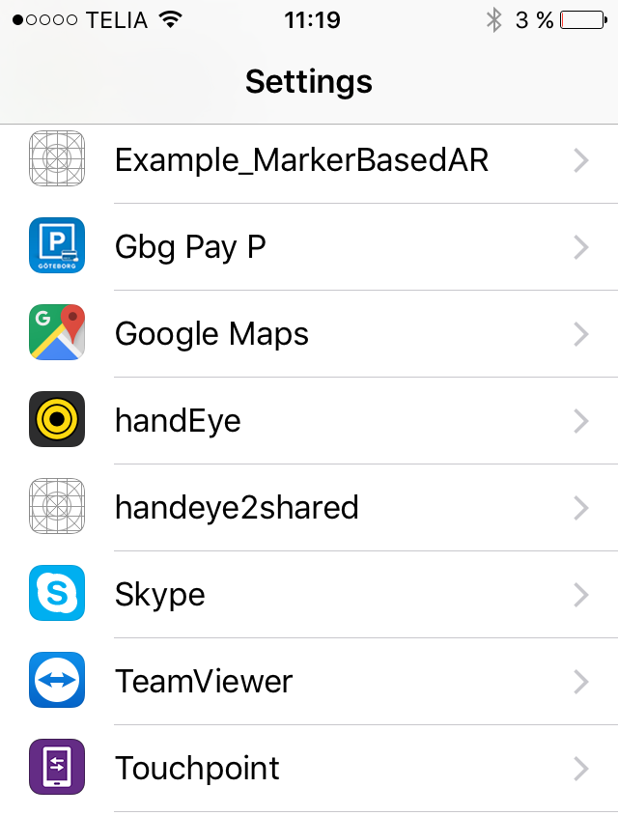

Go to settings, then scroll down to handEye:

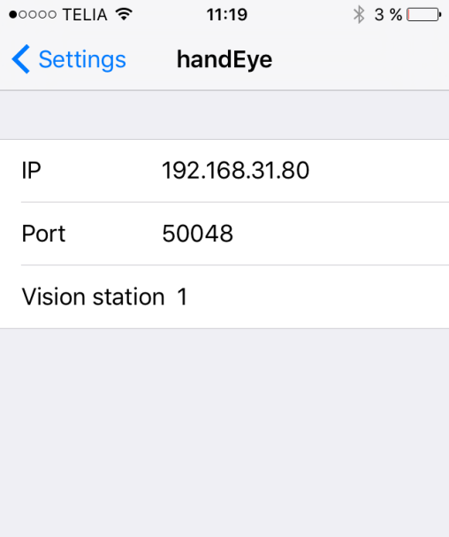

Here, you can manually enter IP Address, Port number and Vision station number:

This information can be found in the Vision2 Setup utility on the tab “handEye”:
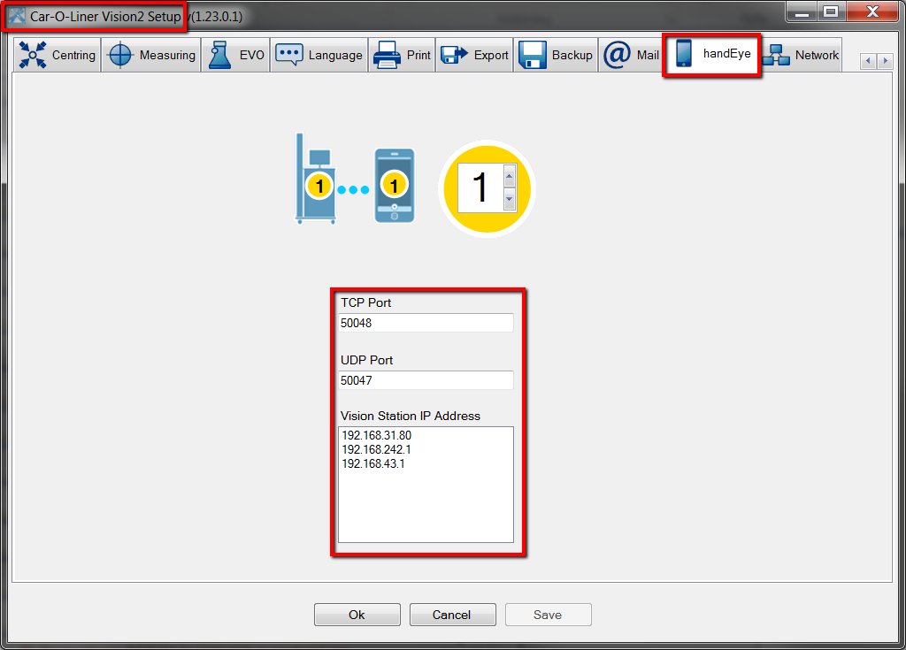

Close the setup, re-launch Vision2 and select create new workorder or open an existing workorder in measuring mode. Start the hand Eye app on your Apple iOS device and the Station should automatically connect. To verify this the workorder name should be visible at the top of the screen:
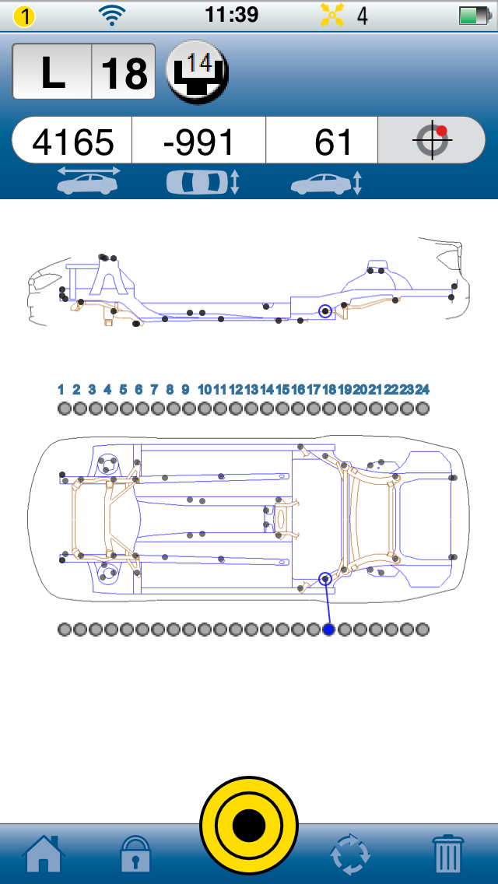
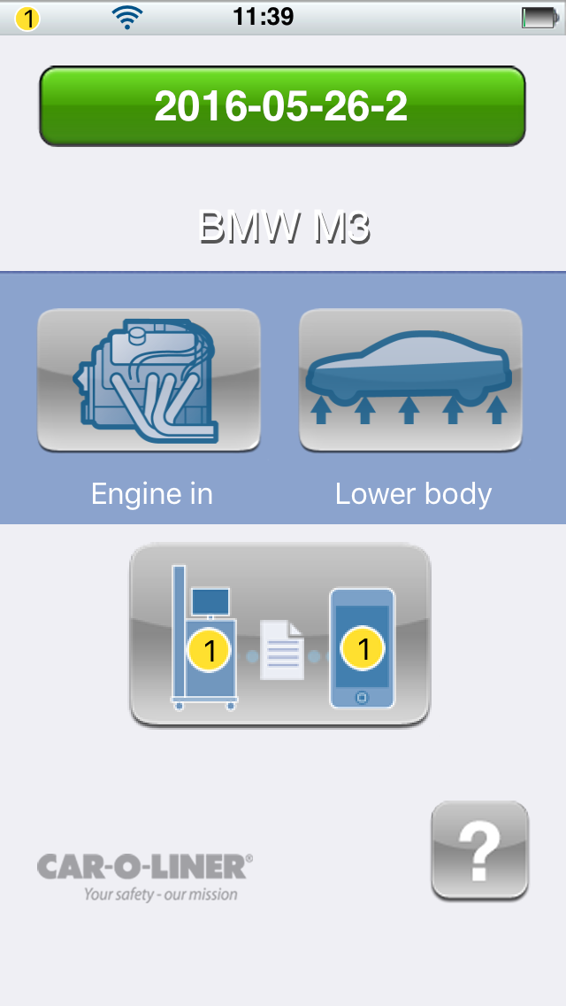

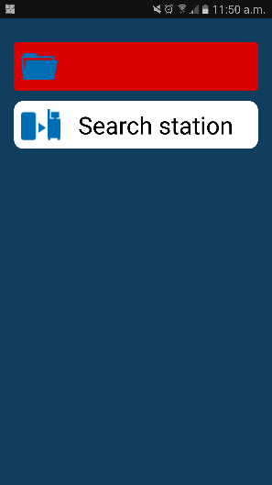
Android

Open the handEye app and click Search station:

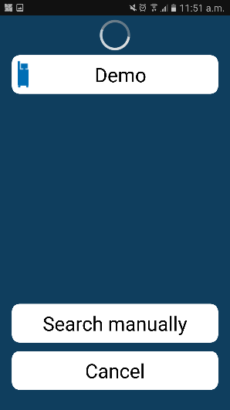
Then Click Search manually:

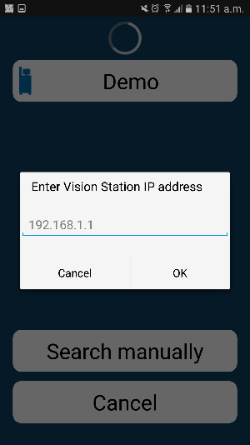

Enter the Vision station IP address (information can be found as shown above in instructions for iOS):

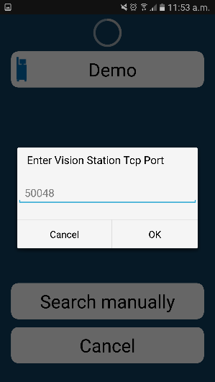

Enter the Vision Station TCP Port (information can be found as shown above in instructions for iOS):

Close the setup, re-launch Vision2 and select create new workorder or open an existing workorder in measuring mode. Start the hand Eye app on your Apple iOS device and the Station should automatically connect. To verify this the workorder name should be visible at the top of the screen:
